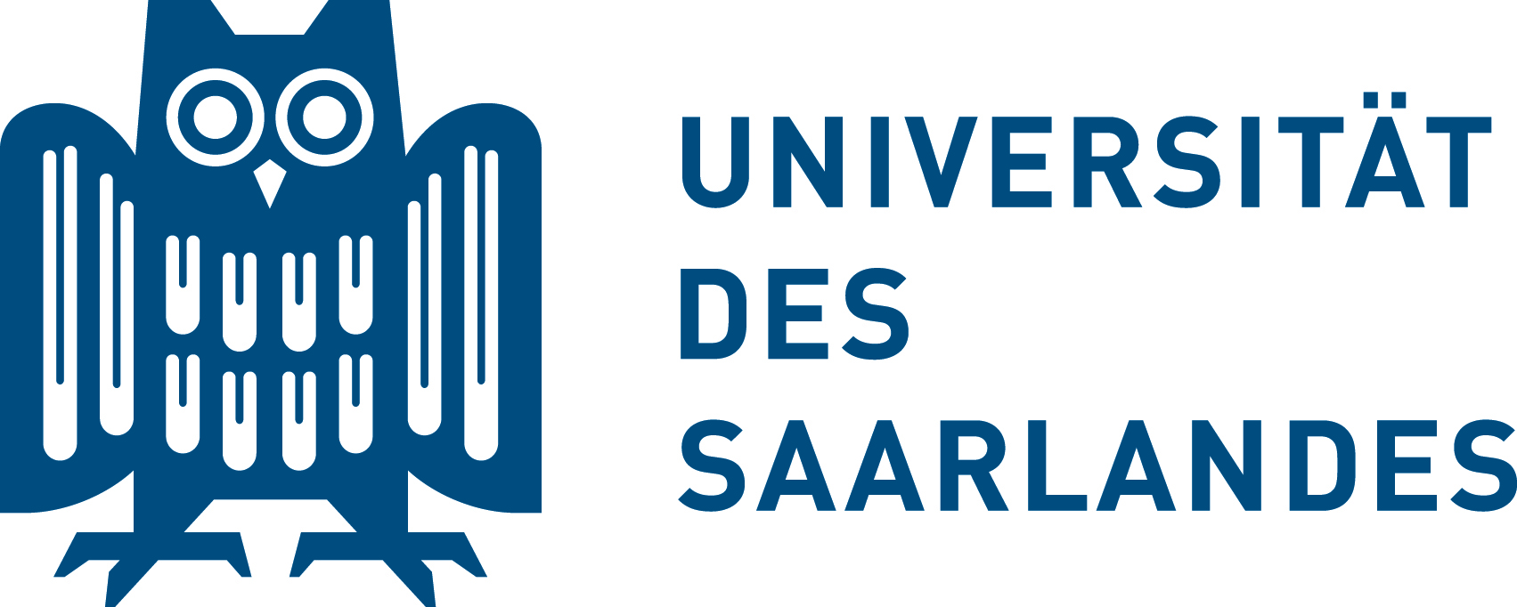

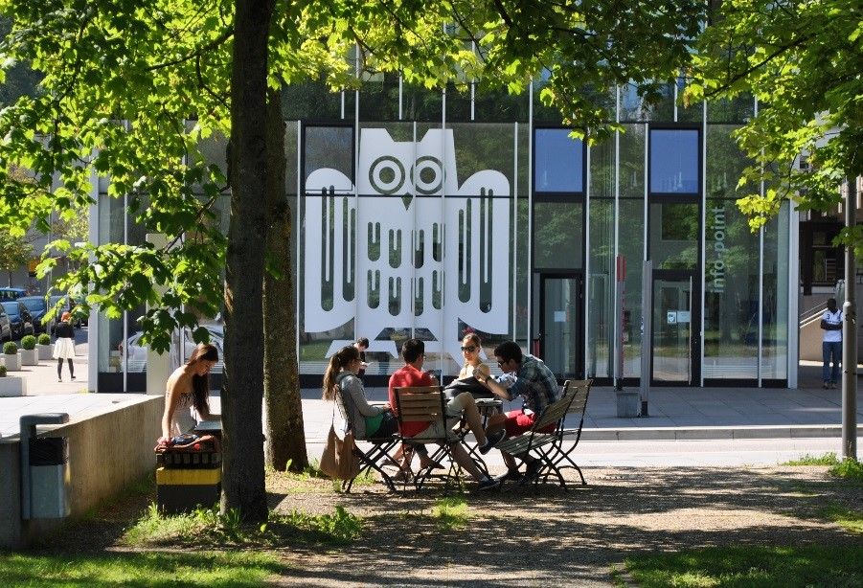

Leibniz-Preisträger

**9**

Erasmus+ Staff Training Week  
"Studying Europe: European focus in teaching and cooperation at Saarland University”  
(19.5. – 23.5.2025)

International Office | Saarland University

Program

Monday, May 19th (Building C7 4, Room 1.17)

0900 Meeting point Campus Center, bus station in the front of building A 4 4

0915 – 1000 Registration (Building C7 4)

1000 – 1015 Welcome address by the Vice-President for Internationalization and European Relations, Prof. Dominik Brodowski

1015 – 1030 Welcome address (Europe Direct; Europametropole)

1030 – 1050 CEUS | Cluster for European Research (Anne Rennig, CEUS)

1050 - 1105 European focus and European values for all: Europaicum Certificate at Saarland University (Elisabeth Marx, CEUS)

1105 – 1200 Who are you?HumanBingo

1200 – 1330 LUNCH BREAK: Restaurant at the Sportcampus

1330 – 1530 Cheque pick-up and cashing at Bank 1 Saar

1600 Cultural activity in the city

Tuesday, May 20th (Building C7 4, Room 1.17)

0900 – 0945 Guided Campus Tour

0945 – 1005 Studying and Research across Borders (Uni GR) (Eva-Maria Hengsbach, International Office)

1005 – 1025 Border Studies - A Master’s Program on Borders and Border Regions (Prof. Astrid Fellner, North American Literary and Cultural Studies)

1025 – 1045 European School of Materials (EUSMAT) at Saarland University (Dr. Flavio Soldera, Material Sciences)

1045 – 1145 COFFEE BREAK: Meet the faculties

1145– 1230 Networking Event (Speed Dating)

1400 Meeting at the train station to visit the steel works Völklinger Hütte

Wednesday, May 21st (Building C7 4, Room 1.17)

0900 – 920 German language appetizers (Dr. Oxana Brandes, International Study Centre Saar)

0920 – 0945 Borderlanguaging: Multilingual Practices on the Border (Dr. Eva Nossem, North American Literary and Cultural Studies)

0945 – 1020 Saarland as a European Model (Volker Venohr, Historian) – online/hybrid

1020 – 1100 COFFEE BREAK: Meet the students

1100 – 1140 Multilingual practices at the University: How to deal with different languages and academic cultures in the Greater Region (Dr. Elisabeth Venohr, German Studies)

1140 – 1200 Trilingual Campus (Helen Weber, International Relations Division)

1200-1300 LUNCH BREAK (Catering)

1300-1430 Workshops

1430-1515 Presentations

Thursday, May 22nd Visit to the European Parliament and Strasburg

800 Bus departure from Fernbusbahnhof

1000 – 1200 Visit of the European Parliament in Strasburg

1330– 1530 Guided tour through the city

1530-1730 Free time in the city

1800 Bus departure to Saarbrücken

2000 Arrival in Saarbrücken

Friday, May 23rd (Building C7 4, Room 1.17)

0900 – 920 German language appetizers (Dr. Oxana Brandes, International Study Centre Saar)

0920 – 940 Capacity Building Project: CHAin - Internationalisation of Cambodian Higher Education (Bettina Jochum, International Office)

940 – 1000 International Law School and Projects at Europa Institut (Mareike Fröhlich, Europa-Institut)

1000 – 1020 Jean Monnet Chair (Fabienne ###, Europa-Institut)

1020-1050 Coffee Break

1050-1110 T4EU Staff Development (Vivien Seimetz, Human Ressources)

1110-1130 Career Service for international students (Julia Bellmann, International Office)

1130-1200 Quiz

1200-1215 Certificates